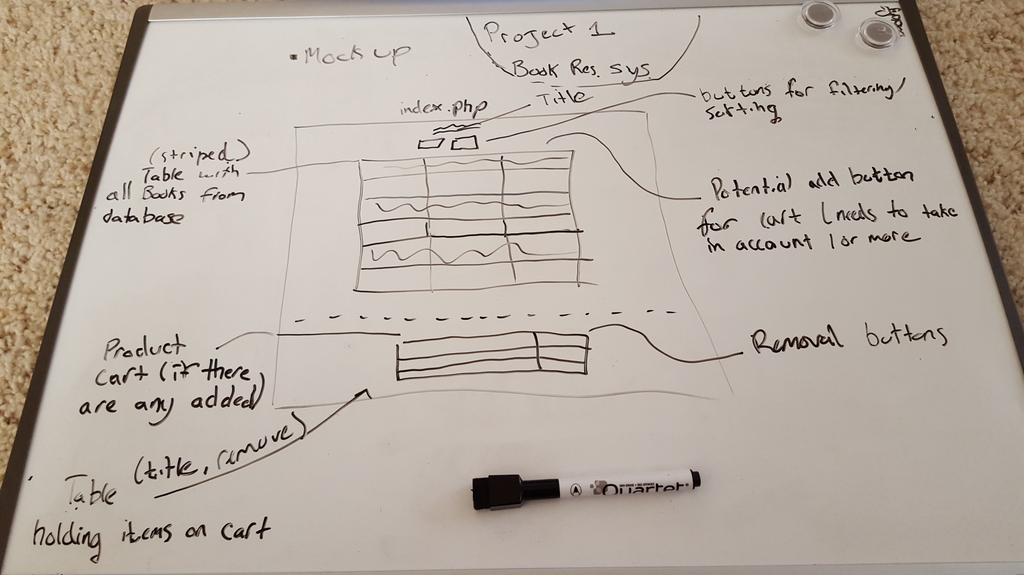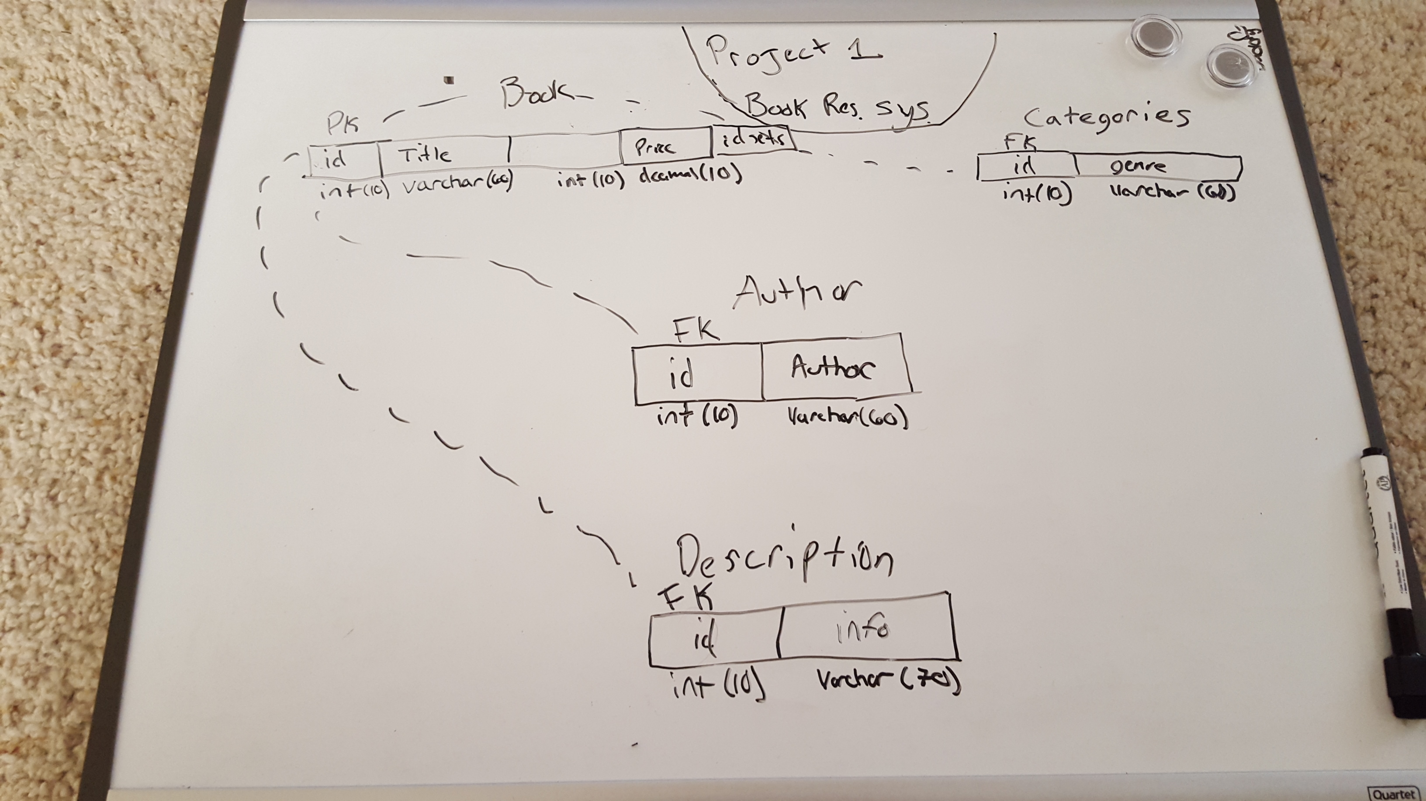

User Story

1. As a customer on this website, I want to be able to view all products that are for sale.

I want to be able to sort and group these items to make it easier to find what I want.

I want a shopping cart that shows what I have in the cart that links to a final summary page with prices.

Acceptance Criteria: UI Must be functioning

Adding items carry value by quantity